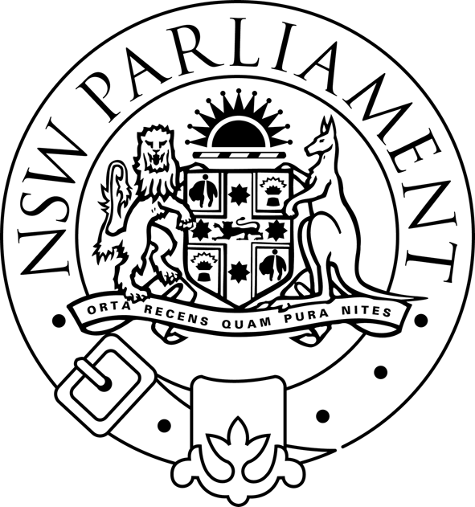
LEGISLATIVE ASSEMBLY

Parliament of New South Wales · Macquarie Street · Sydney NSW 2000 · Australia

NOTICE OF PUBLIC HEARING

REVIEW OF FIRE SERVICES FUNDING
Friday, 7 May 2004
Room 814/815, Parliament House, from 9:00 am
Time | Organisation | Witness
9:00 | Professional Financial Solutions | Mr Doug Drysdale  Principal  Mr Thach Huynh, Associate
9:45 | Property Council of Australia | Mr Ken Morrison  Executive Director – NSW Policy  Ms Cheryl Thomas  NSW Policy Adviser
10:15 | Insurance Council of Australia | Mr Alan Mason  Executive Director  Mr Allan Hansell  Manager NSW and ACT
10:45 | Morning tea
11:00 | ARIMA Ltd | Mr Tim Banks. Director  Mr Jason Hall  Special Interest Group Coordinator  Mr Chris Mitchie - Special Interest Group Associate  Mr Sean O'Brien  Special Interest Group Associate
11:30 | Council of Social Services in NSW (NCOSS) | Gary Moore  Director
12:00 | Local Government Association of NSW and the Shires Association of NSW | Councillor Robert Gledhill,  Shires Association Executive  Councillor Alan Smith,  Local Government Association Executive  Mr Shaun McBride, Policy Officer, Economics and Development  Mr Warren Taylor  Acting Director Strategic Services

